TITLE:
Smart Cane for Enhanced Safety and Environmental Awareness

AUTHORS
[Amir Muizzuddin Bin Noraidil Razman], [Muhammad Haikal Hanif Bin Abdul Razak] , [Ahmad Ilham Bin Abdul Aziz], Department Of Mechatronic Engineering , International Islamic University Malaysia ,

ABSTRACT
This project presents the design and development of a Smart Cane system aimed at improving the safety and mobility of visually impaired users. The proposed system integrates fall detection, obstacle detection, and automatic night-time illumination using an ESP32 microcontroller as the central processing unit. A motion sensor module (MPU6050) is employed to detect accidental falls and trigger an emergency alert through a buzzer. An ultrasonic sensor (HC-SR04) is used to detect obstacles in front of the user and provide timely feedback. Additionally, an automated LED torch controlled by a light-dependent resistor (LDR) ensures visibility in low-light or dark environments. When a fall is detected, the system automatically sends an emergency alert with location information to a registered guardian. Additionally, a blinking LED system improves user visibility during night-time road crossing.Bluetooth communication is implemented to enable data transmission between the Smart Cane and a mobile phone. Experimental results demonstrate that the system operates reliably and enhances user safety, awareness, and confidence during daily mobility.

1. INTRODUCTION

Walking canes are a major part of everyday mobility for those with visual impairments. Although the conventional white cane works well for identifying impediments at ground level, it is insufficiently aware of environmental risks such elevated barriers, slick surfaces, and emergency circumstances. Additionally, traditional canes don't help notify others when a user falls or needs help, especially at night or in remote locations.

According to earlier research, smart cane systems with sensors and feedback systems can greatly increase mobility and lower collision rates when compared to conventional canes. According to research published in the International Journal of Design, visually impaired people can move more safely with smart canes that combine vibrotactile feedback and sensor-based detection as long as usability, weight, and feedback clarity are carefully taken into account.

Fall detection, emergency alarms, and visibility functions can now be incorporated into a small, reasonably priced assistive gadget thanks to developments in embedded systems and wireless communication. The goal of this project is to create a smart cane that will increase walking safety, particularly at night, and guarantee prompt aid by alerting guardians in an emergency.

2.METHODOLOGY
2.1 Project Development
Overall a block diagram is an overview of the entire system such that the connection between input, output and microcontroller can be explained. The project on the smart cane has 3 circuits which can be categorized as RDS (Rain Detection System), ODS (Obstacle Detection System) and LAS (Location Alert System). The block diagram will start with a simple push button to turn on the system. On the other hand, Fig 2 will show the flow of ODS and RDS that will use Arduino as microcontroller and LAS will use ESP 32 as microcontroller. The following single diagram demonstrates the collaboration of all the systems that secure the efficiency of the project in general . Fig 3 indicates the flow chart of the all systems that represents the work principle of Smart Cane project.

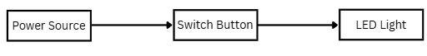
Fig 1. Indicator that the Smart Cane turned On

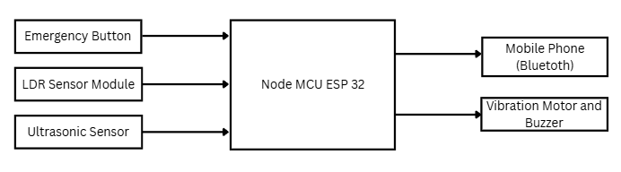
Fig 2.

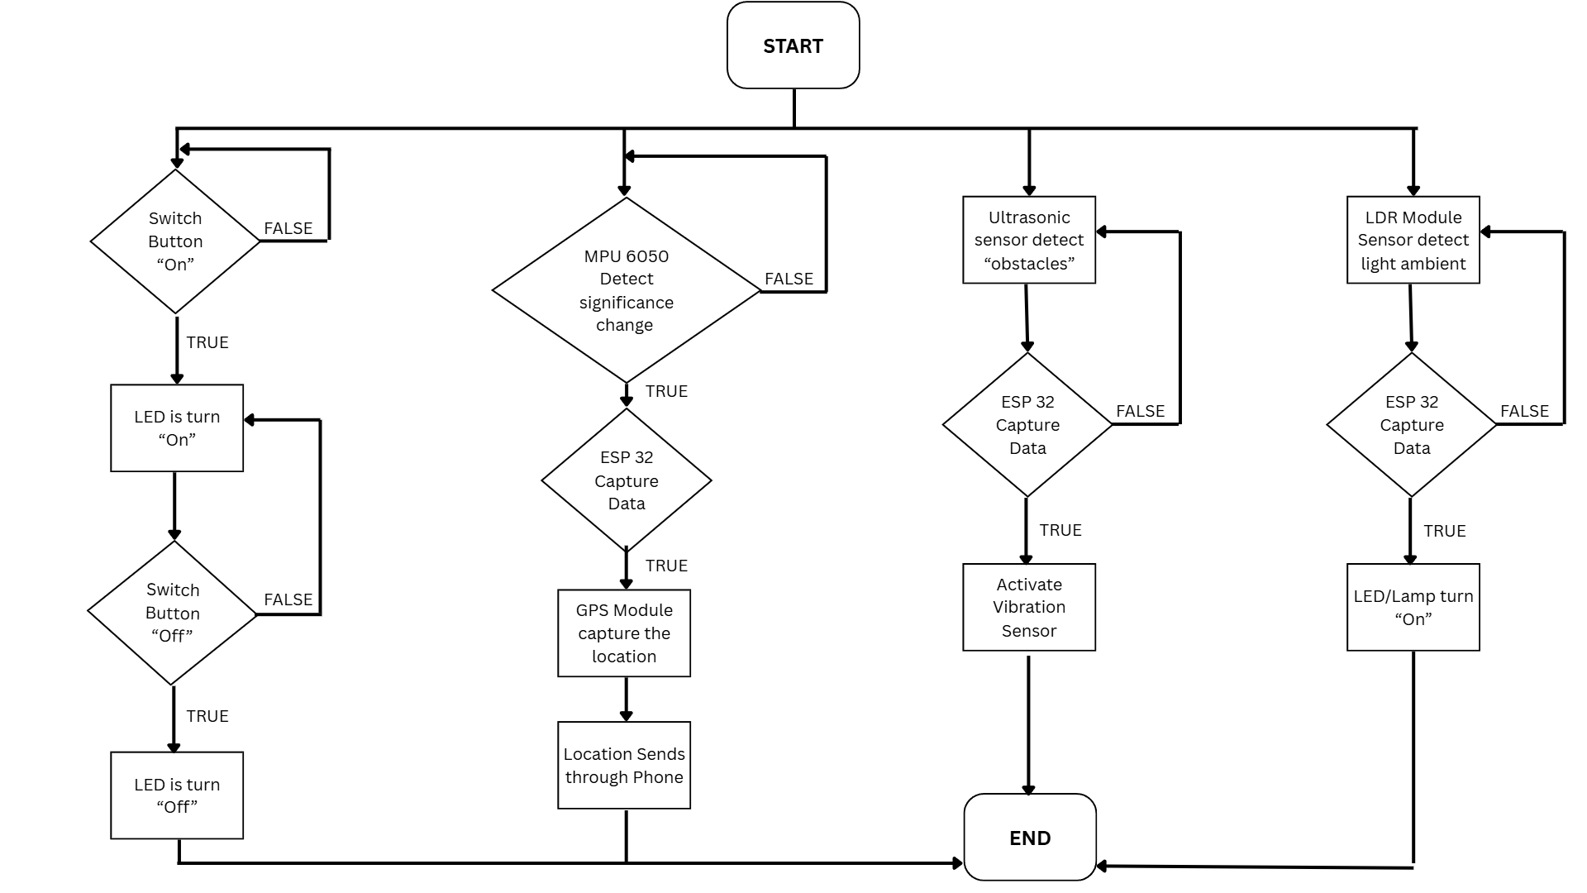
Fig 3.

2.2 SCHEMATIC DIAGRAM AND PROTOTYPE SETUP:

Figure 1 illustrates the schematic diagram of the smart cane system, which integrates several modules powered by a central ESP32 microcontroller. The electrical design includes an MPU6050 accelerometer and gyroscope module dedicated to a fall detection system that triggers an emergency Buzzer alert if an accidental fall is detected. For environmental awareness, an HC-SR04 Ultrasonic Sensor is utilized for obstacle detection, providing the user with distance-based feedback. Additionally, the system features an automated LED Torch controlled by an LDR (Light Dependent Resistor), which senses ambient light levels to ensure visibility in dark conditions. All data and alerts are processed by the ESP32, which facilitates a Bluetooth data system for communication with a mobile phone. In the meantime, Figure 2 exhibits the prototype design setup, showing the physical arrangement of these components on the cane shaft and handle to ensure ergonomic use and optimal sensor placement.

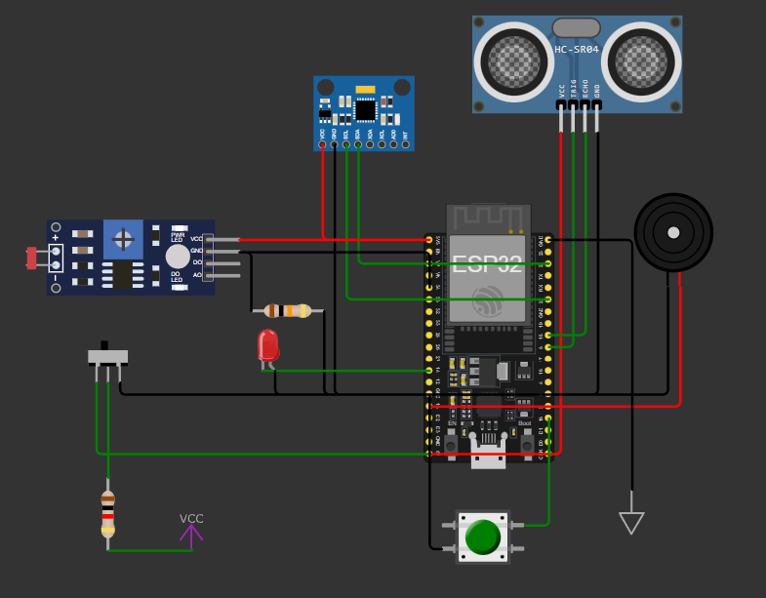
Fig. 1

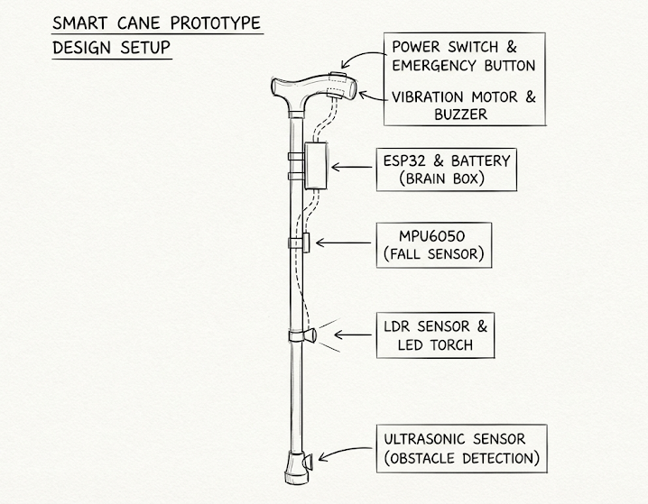
Fig. 2

